***Automated Waste Segregation and Collection Using Conveyor Belt***

**Abstract**

The increasing environmental problems brought on by inappropriate garbage disposal have made effective waste management a crucial concern in recent years. Ineffective trash collection and recycling procedures result from the labour-intensive, time-consuming, and error-prone nature of traditional waste segregation techniques. garbage management has become more and more in need of automation and intelligent solutions, particularly in metropolitan settings where garbage production is always increasing. By utilizing automation and sensor-based technologies, our suggested method, the Automated Waste Segregation and Collection method, tackles these issues. Waste is more effectively separated into dry, moist, and metal categories by using sophisticated methods. To regulate the trash processing process, the system integrates an Arduino Uno with a number of sensors, such as metal detectors and an image processing camera. In order to monitor waste weight and provide crucial information for the best collection schedules, it also has load cells beneath the dry and wet bins. Inaccurate sorting, contamination, and ineffective recycling are some of the problems with traditional waste collection techniques. Optimizing collection schedules is further made more difficult by the human tracking of waste weight. These problems are resolved by our technology, which offers a trash sorting solution that is more precise and efficient. It guarantees appropriate waste management by automating the procedure and supplying real-time data, allowing for prompt and precise collection based on actual waste quantities. Our technology plays a crucial role in sustainability, enhances sorting accuracy, and drastically lowers human interaction when compared to current systems. The technology represents a significant breakthrough in the waste management industry due to improved recycling procedures and less environmental effect.

**Keywords:** Waste Segregation, Automated Waste Collection, Conveyor Belt System, Arduino Uno, Load Cells, Waste Classification, Image Processing, DC Motors, Relay Module, Sensor Integration.

**Introduction**

Effective waste management has grown in importance in recent years as a result of the mounting environmental problems caused by inappropriate garbage disposal. Traditional waste management systems are under a lot of strain as the amount of waste produced rises along with urban populations. These systems frequently use labour-intensive, inefficient, and human error-prone manual trash sorting and collection methods. Poor recycling rates, high levels of pollution, and an increasing impact on the environment are the results of this. Furthermore, it is challenging to optimize waste management operations when trash weight and collection schedules are manually tracked.

Waste management is increasingly in need of automation and smart technologies to meet these difficulties. Waste collection and segregation procedures can be streamlined by automated solutions, which also increase accuracy and decrease the need for human intervention. Automated systems can categorize garbage into appropriate categories (e.g., dry, wet, and metal) by using sensors, such as infrared (IR) sensors, metal detectors, and image processing cameras. Furthermore, load cells positioned beneath bins are able to track the weight of waste, offering useful information for the best possible timing of collection.

These issues are intended to be addressed by the Automated Waste Segregation and Collection System. This system can precisely classify waste and track its weight during the collecting process by combining cutting-edge sensor technologies, an Arduino Uno-based control system, and automated conveyor belts. The system is an efficient way to enhance waste management procedures in urban settings because of its dependability, affordability, and capacity to handle different kinds of garbage. The system encourages more effective recycling and garbage disposal by automating waste sorting, measuring weight, and eliminating human participation. This plays a crucial role in sustainability and lessens environmental impact.

Additionally, the optimization of waste management procedures can be greatly aided by the deployment of such automated systems. The technology enables improved waste collection scheduling by giving real-time data on waste weight and kind, which lowers needless trips and related expenses. Additionally, by directing properly sorted garbage to the appropriate recycling streams and reducing contamination, it improves the efficiency of recycling processes. In addition to improving operational efficiency, the implementation of this system promotes a more environmentally friendly method of waste management, which is in line with international initiatives to lessen landfill trash and advance circular economies.

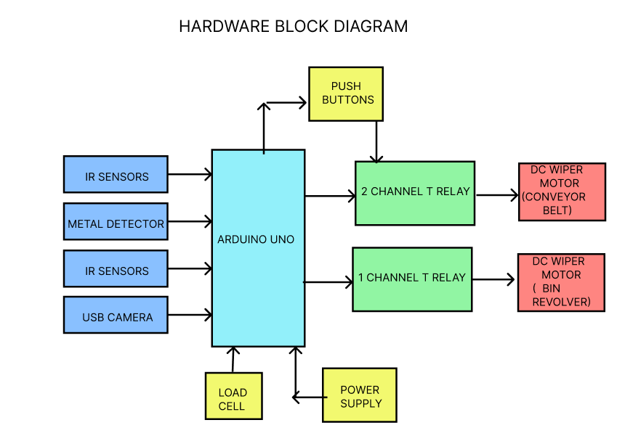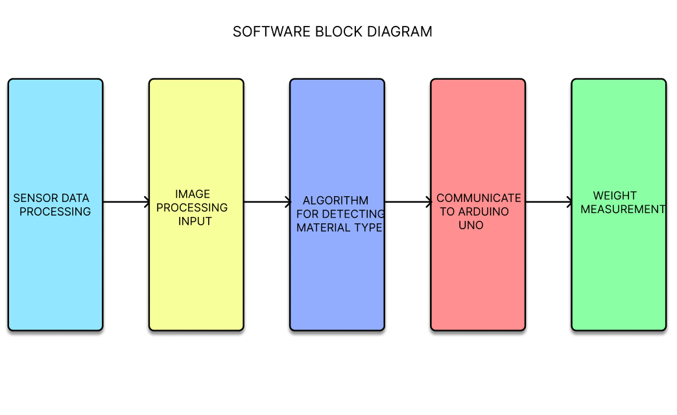

**Methodology**

**System Design and Integration**

The Arduino Uno microcontroller is the central component of the Automated Waste Segregation and Collection System and is essential to overseeing the entire operation. The Arduino Uno is configured to manage different sensor inputs and regulate outputs that power the waste bins, motors, and relays. Through a number of relay modules, this microcontroller communicates with the various components of the system. These modules allow the activation of various mechanical components, including the DC wiper motors that power the dustbin rotation mechanism and conveyor belt.

The roller conveyor belt used in the system is made of L-channel sheet metal and a mild steel frame. The garbage must be moved between the three categories—dry, moist, and metallic—by means of this conveyor belt. Two DC wiper motors power the movement, and they are managed by relays that are triggered by signals from the Arduino Uno. In order to ensure that every sort of garbage is sent to the appropriate bin, the conveyor belt system is essential in moving the waste towards the segregating units.

The system incorporates a number of sensors in addition to the motors, which are crucial for trash identification and segregation. These sensors consist of a USB camera, metal sensors, proximity sensors, and infrared sensors. In order to detect the presence of garbage, the IR sensors are placed at different positions along the conveyor. Depending on the position of the waste, the sensors will either start or stop the system. In order to separate metallic items from non-metallic garbage, the metal sensor is employed to detect them.

Even more crucially, the USB camera aids in the system's ability to categorize the garbage according to its visual attributes. The camera can differentiate between dry, wet, and metallic waste thanks to image processing approaches that are either based on machine learning algorithms or pre-defined visual cues. For instance, the system may use colour or texture to identify dry garbage, whereas visual cues like water content are used to identify wet waste. The Arduino Uno receives this camera data and uses it to make decisions.

The sorting process is further improved by the use of proximity sensors, which guarantee that waste is appropriately classified according to its movement and distance from the sensor. Together with the camera and metal detectors, these sensors form an effective system that can manage different kinds of waste without the need for human assistance.

**Waste Segregation Process**

The sorting process starts as soon as the waste is put on the conveyor belt. Waste on the belt is initially detected by the infrared sensors. The conveyor belt is started and the waste is moved towards the segregation section when the Arduino Uno detects a piece of waste and activates the DC wiper motor. The metal sensor checks the waste for metallic items as it moves along the belt. The sensor diverts metal objects into the appropriate metal bin by activating the related relay if it detects metal.

As the debris moves up the conveyor, the camera keeps taking pictures of it. The technology is able to classify the waste since the image is processed in real-time. The image processing algorithm determines the visual signals that form the basis of the classification. Once the sort of garbage has been detected, the Arduino Uno tells the motors to rotate the appropriate dustbin into place. Wet and dry waste are identified independently.

The dustbins' rotation is managed by the system using 2-channel T-relays and optocouplers. To ensure safe operation, the relays separate the low-voltage control pins of the Arduino from the high-voltage motor circuits. The dustbins' forward and backward movements are managed by the 2-channel relay, which makes sure they rotate as necessary to match the proper waste type. The dustbins are constructed from sturdy materials and are intended to hold a variety of waste products without leaking or shattering. Additionally, load cells that are positioned at the bottom of the dustbins weigh the waste as it is deposited.

**Load Cell Integration for Weight Measurement**

After the waste has been separated, it is placed in either the metal, wet, or dry bins. To measure the weight of the waste as it builds up, the system has load cells beneath the dry and moist bins. The Arduino Uno receives real-time data from the load cells and utilizes it to calculate the bins' fill level. The technology determines when to empty the bins based on weight measurements, making sure that waste is taken out before it overflows.

Instead of depending on manual or pre-scheduled checks, the integration of the load cells is essential to guaranteeing that waste collection occurs at the best times. Because bins are only emptied when they reach their appropriate weight limit, this feature helps to reduce inefficiencies. Additionally, the weight data is shown on a screen for management and monitoring in real time. Waste management staff can get alerts when bins are full and need to be emptied because to the data's remote accessibility.

**Power Supply and System Control**

All parts of the system, including the sensors, motors, and Arduino Uno, are powered by a 12V, 7.5Ah red acid battery. The battery was picked because it is long-lasting and can power the system for long periods of time. The sensors' and relays' low power consumption guarantees that the battery runs effectively, reducing the need for frequent replacement or recharging.

The system's self-sufficiency and ability to function without an external power grid are further guaranteed by the use of a battery power supply. The system's independence makes it perfect for deployment in a variety of settings, particularly those with erratic or non-existent electrical supplies.

**Data Visualization and Monitoring**

For convenient monitoring, the system's acquired data—such as weight readings, trash classification, and sensor status—is shown on a screen. This enables operators to monitor the waste segregation and collection process's progress. Additionally, the display gives instant feedback on the weight of the waste in each bin, facilitating prompt scheduling decisions.

IoT capabilities can also be added to the system, allowing for remote waste collection process monitoring. Waste management teams can optimize collection schedules and resource allocation by receiving notifications and updates regarding the system's status.

**Hardware Requirements**

**Arduino Uno**: Microcontroller to control sensors, motors, and relays.

**IR Sensor**: Detects presence of waste on the conveyor belt.

**2-Channel T-Relay with Optocoupler**: Controls the rotation of the dustbins.

**1-Channel T-Relay with Optocoupler**: Controls the conveyor belt’s forward motion.

**Proximity Sensor**: Detects the position of waste for sorting.

**Push Switch**: Used for starting and stopping the system.

**Load Cell**: Measures the weight of waste in the bins for collection.

**Battery (12V, 7.5Ah)**: Provides power to all components of the system.

**DC Wiper Motors**: Powers the conveyor belt and rotates the dustbins.

**USB Camera**: Captures images of the waste for classification using image processing.

**Software Requirements**

**Arduino IDE**: Software to write and upload code to the Arduino Uno.

**Image Processing Algorithm**: Software to process images from the USB camera to classify waste as dry, wet, or metal.

**Data Visualization Software**: Displays weight data from load cells and system status.

**Serial Communication**: Enables communication between the Arduino and connected components like the camera or display

**Existing Systems**

The majority of modern systems rely on semi-automated or manual methods for waste segregation, classifying waste using simple methods such conveyor belt-based sorting, weight sensors, or optical recognition. These systems are frequently constrained by their incapacity to adjust to different waste kinds and operational contexts, especially in bigger, more intricate contexts like hospitals, factories, or sizable municipal waste management facilities. In these current configurations, the conveyor belt systems are typically utilized to move waste to designated bins, where it is separated either manually or via simple sorting techniques. Despite automation attempts, these systems have a number of drawbacks. One significant problem is the need on human operators to manually handle or deposit waste in the proper locations, which lowers the effectiveness and speed of the sorting process.

Furthermore, a lot of current systems rely on simple sensors like proximity or weight sensors, which are ineffective at differentiating distinct waste types, particularly when objects overlap or are distorted. A mixed bundle of paper and plastic, for instance, can be mistakenly classified as a single category, contaminating the final segregated bins. Additionally, these devices' outdated image processing algorithms are imprecise and slow, making it difficult to classify waste that is partially blocked or near other objects. Additionally, because the majority of these systems rely on fixed-location sorting devices like robotic arms or stationary conveyors, they are less adaptable in dynamic contexts where waste is not regularly disposed of in a predictable way.

Last but not least, a lot of conventional systems still require human labor, which poses a serious health risk to employees, particularly when managing biohazardous waste. Concerns regarding health and safety are raised by the possibility of contamination and the possibility of direct contact with dangerous materials.

**Limitations**

* **Lack of Flexibility:** Existing systems, particularly those with conveyor belts or fixed robotic arms, are not adaptable to different environments or capable of handling varied waste patterns.
* **Inaccurate Waste Classification:** Basic sensors and outdated image processing techniques fail to properly categorize waste, especially when objects are partially hidden, deformed, or overlapping.
* **Health Risks:** Manual waste segregation exposes workers to biohazardous materials, increasing the risk of contamination and health hazards.

**Proposed Systems**

By combining sophisticated automation, sensor integration, and intelligent classification approaches, the proposed Automated trash Segregation and Collection System seeks to completely transform trash management. An Arduino Uno is at the heart of this system, coordinating the actions of numerous parts like relays, motors, and sensors. In order to categorize the waste as dry, wet, or metal, the system uses algorithms to process photos of the waste on the conveyor using a USB camera. Motors managed by T-relay modules are then used to precisely sort the waste into the appropriate bins. In order to assess the weight of the garbage and enable periodic collection based on real-time data, the system also has load cells positioned beneath the dry and wet waste containers.

Waste segregation is made far more accurate and efficient by the system's capacity to sort waste on its own without the need for human assistance. Infrared and proximity sensors track the passage of waste on the conveyor and make sure everything runs properly. The entire garbage sorting procedure is automated and smooth thanks to the DC wiper motors that power the conveyor and the revolving bins. Additionally, the system may run on its own using a 12V battery, guaranteeing long-term operation in settings where waste is generated continuously.

In comparison to current systems, the suggested system has a number of advantages. It reduces human mistake and guarantees more accurate classification by combining real-time data and many sensors. Additionally, the method reduces the possibility of exposure to hazardous materials by doing away with the necessity for manual handling. This system is more adaptable to various waste streams and surroundings than conventional conveyor-based systems, which are static and necessitate the manual placement of waste. Furthermore, the load cell integration offers insightful information on waste amounts, facilitating prompt collection and streamlining waste management plans.

**Advantages**

* **Improved Accuracy**: The system’s sensor-based approach, coupled with real-time data collection, ensures more accurate waste classification compared to traditional methods.
* **Flexibility:** Unlike fixed-location systems, this system can be easily adapted to various environments and waste management scenarios, offering a high level of mobility and scalability.
* **Enhanced Safety:** By automating the waste segregation process, the system reduces human exposure to biohazardous and harmful waste, ensuring a safer working environment for staff.

**Conclusion**

The Automated Waste Segregation and Collection System developed for efficient waste management represents a major breakthrough in automating the waste sorting and collection process. By incorporating advanced automation, sensor integration, and intelligent waste classification through image processing and load cells, this system offers a reliable, precise, and fully autonomous solution. The integration of the Arduino Uno, IR sensors, proximity sensors, USB camera, and DC wiper motors enables the system to operate seamlessly, ensuring effective waste segregation with minimal human intervention.

With the use of sensors like the metal sensor, IR sensors, and the image processing system, the system significantly reduces the chances of misclassification, enabling accurate sorting of dry, wet, and metal waste. This reduces errors in waste categorization, ensuring a more sustainable recycling process and reducing the impact of improper waste disposal. The incorporation of load cells further adds a layer of efficiency by providing real-time data on waste quantities, facilitating periodic collection based on actual waste levels rather than arbitrary schedules.

The system’s modular design and flexibility make it suitable for various waste management environments, and it can be adapted to meet the specific needs of different sectors. The robust hardware configuration, including the 12V battery and DC motors, ensures long-lasting operation without the need for frequent maintenance or recharging. The elimination of manual handling further enhances the safety of workers by reducing exposure to potentially harmful or biohazardous materials.

In conclusion, this study demonstrates the effectiveness of integrating automation and sensor technologies in solving real-world problems, particularly in the context of waste management. The Automated Waste Segregation and Collection System provides an innovative, efficient, and eco-friendly solution for waste management, showcasing how automation can play a crucial role in promoting sustainability, reducing human effort, and ensuring better waste processing practices in diverse environments.

**References**

Venkatesh, M., & Gupta, S. (2018). Object Detection in Industrial Applications: A Review of Machine Learning Approaches. *Robotics and Autonomous Systems*, 109, 23-32.

Suman, K., & Pandey, M. (2020). Hospital Automation and Robotics in Healthcare: A Survey. *International Journal of Robotics and Automation*, 35(4), 280-295.

Anderson, R., & Bell, G. (2022). Ultrasonic Sensors for Autonomous Navigation in Robotics: Applications in Hospital Robotics. *Journal of Robotic Systems*, 40(1), 12-18.

Sahu, P., & Sahoo, M. (2020). Raspberry Pi as a Platform for Robotics and IoT Applications in Healthcare. *International Journal of Robotics and Automation*, 22(2), 185-198.

Kumar, R., & Sharma, P. (2019). Waste Management and Recycling Automation Using Robotics: A Review. *International Journal of Advanced Robotics*, 30(7), 48-55.

Yadav, P., & Singh, S. (2021). AI and Robotics in Waste Segregation Systems: Future Trends. *Journal of Environmental Technology and Management*, 45(3), 119-127.

Mishra, A., & Bhagat, R. (2017). Implementation of Smart Waste Management Using IoT: A Review. *International Journal of Computer Applications*, 157(2), 25-30.